MGT403
Lecture 26

Advantages of Intrapreneuring over Entrepreneuring
- Capital Sources
- Access to customers
- Infrastructure
- Management Pools
- Leverage on an existing business

Disadvantages of Intrapreneuring over Entrepreneuring
- Continuity of Sponsorship
- P & L Focus
- Short Term Mentality
- Corporate Meddling, Bureaucracy, Decision by committee
- Lack of Passion
- Have to be big to be material
- Aversion to risk

How companies can support the process
- Shorten the search for funding
- Offer a stable pay check as an idea germinates
- Find creative ways to reward employees and let them get rich from their creations
- Can have longer time horizons than venture capitalists have
- Allow people to speak their minds and proceed with their plans if they have sufficient evidence and arguments
- Allow employees to take risks without fear of reprisals
- Have a formal process for moving an idea from research to product to market.
- Understand the right balance between structure and spontaneity

How companies can support Intrapreneurs
- Formation of intrapreneurial teams and task forces;
- Recruitment of new staff with new ideas;
- Application of strategic plans that focus on achieving innovation; and
- Establishment of internal research and development programs are likely to see tangible result
- Support from top level management –
- This support should not simply consist of passive approval of innovative ways of thinking. Ideally, it should also take the form of active support, such as can be seen in mentoring relationships.
- Recognition that the style of intrapreneurialism that is encouraged needs to be compatible with business operations and the organization's overall culture.
- Ensure that communication systems within the company are strong so that intrapreneurs who have new ideas for products or processes can be heard.
- Intelligent allocation of resources to pursue intrapreneurial ideas
10 Commandments of Intrapreneurs
- Do any job to make your project work, regardless of your job description
- Share credit (for success) wisely
- It is easier to ask for forgiveness than permission
- Come to work each day willing to be fired
- Ask for advice before asking for resources
- Follow your intuition about people, build a team of the best
- Build a quiet coalition for your idea; Never bet on a race unless your are running in it
- Be true to your goals, but realistic about ways to achieve them
- Honour your sponsors

Stakeholder’s Management
What are Stakeholders?
Individuals and groups with a multitude of interests, expectations, and demands as to what business should provide to society.
Who Are Business Stakeholders?
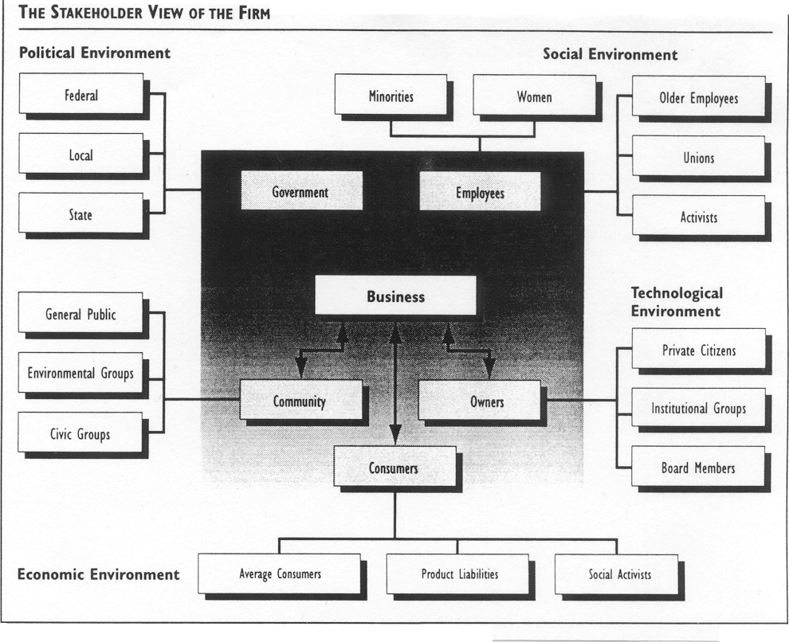
Types of Stake
Stakeholder/Responsibility Matrix
Stakeholders | Economic | Legal | Ethical | Philanthropic
Owners
Customers
Employees
Community
Public at large
Social Activists
Other

Power/Interest Grid
- Two-by-two matrix with power on one axis and interest on the other
- Each stakeholder is placed on the Grid based on its power and interest

Stakeholder Theory
Organizational management is largely influenced by the opinions and perspectives of internal and external stakeholders. A stakeholder is any group, individual, or community that is impacted by the operations of the organization, and therefore must be granted a voice in how the organization functions. External stakeholders have no financial stake in the organization, but are indirectly influenced by the organization’s operations.

Internal Stakeholders
Internal stakeholders are individuals or groups who are directly and/or financially involved in the operational process. This includes employees, owners, and managers. Each of these groups is potentially rewarded directly for the success of the firm.

Employees
Employees are primary internal stakeholders. Employees have significant financial and time investments in the organization, and play a defining role in the strategy, tactics, and operations the organization carries out. Well run organizations take into account employee opinions, concerns, and values in shaping the strategy, vision, and mission of the firm.

Managers
Managers play a substantial role in determining the strategy of the organization, and a significant voice in operational decisions. Managers are also accountable for the decisions made, and act as a point of contact between shareholders, the board of directors, and the organization itself.

Owners
Owners (who in publicly traded organizations can include shareholders) are the individuals who hold significant shares of the firm. Owners are liable for the impacts the organization has, and have a significant role in strategy. Owners often make substantial decisions regarding both internal and external stakeholders.

Customers
Understanding the needs of an organization’s core customer base, and optimizing operations to best fill those needs, is therefore a significant part of managing a business. Interacting with customers through social media, emails, storefronts, user testing groups, and the delivery of services and goods is an important aspect of maintaining a strong community (and a strong sense of what customers want from the organization).

Suppliers
Suppliers are closely related to organizations as key external stakeholders. Timely payments, shipments, communication, and operational processes are key to maintaining a strong relationship with this stakeholder group.

Local community
A business can be a great benefit to a community, providing tax money, local access to unique goods and services, jobs, and community development programs. However, a business can also be a drain on a community by increasing traffic, creating pollution, hurting small businesses, and altering real estate prices. As a result, businesses must look at the needs of the community, and ensure that negative repercussions are minimized while community engagement is maximized.

Government
Governments tax businesses, and therefore have a firm stake in their success. Governments can in fact be considered primary stakeholders, considering the profit motive involved. Governments also provide regulatory oversight, ensuring that accounting procedures, ethical practices, and legal concerns are being handled responsibly by business representatives.

Broader Society
As a result of the digital and global economy, a business can have a significant impact on society at large. Manufacturing facilities in developing nations are transforming entire ecosystems. Social networks are collecting vast amounts of data. All of these concepts aren’t intrinsically good or bad, but managing them to ensure outcomes are positive for society as a whole is a critical responsibility.

Power/Interest Grid
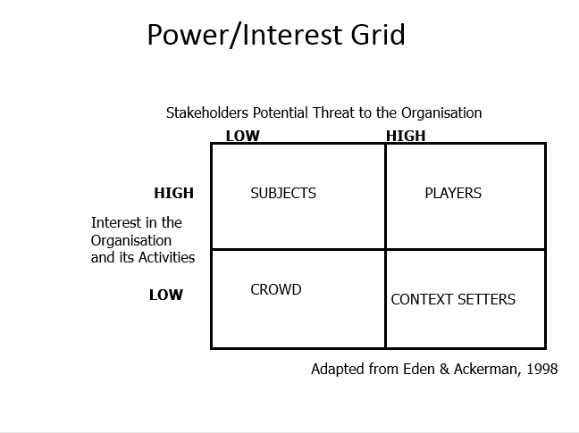
Strategies to tackle groups
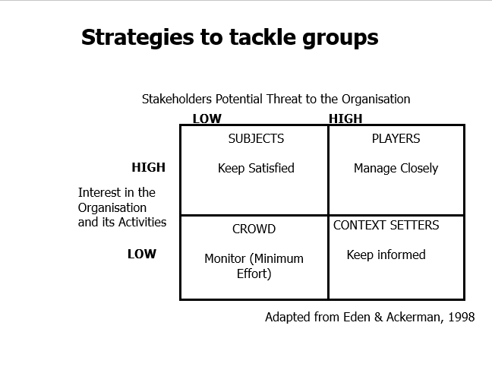
- High power - High interest: these are the stakeholders are decision makers and have the biggest impact on the project success and hence you must closely manage their expectations.
- High power - Low Interest: these are the stakeholder needed to be kept in loop, these stakeholders need to be kept satisfied even though they aren’t interested because they yield power. These type of stakeholders should be dealt with cautiously as well since they may use their power in a not desired way in the project if they become unsatisfied.
- Low power – High interest: keep these people adequately informed, and talk to them to ensure that no major issues are arising. These people can often be very helpful with the detail of your project.
- Low power - low interest: monitor these people, but do not bore them with excessive communication.
(Source: https://www.projectmanagement.com/wikis/368897/Stakeholder-Analysis--using-the-Power-Interest-Grid)
https://courses.lumenlearning.com/boundless-management/chapter/business-stakeholders/

