COMSATS University Islamabad, Virtual Campus

MGT403 Entrepreneurship

Lecture 21 Handouts

Marketing
Marketing is the activity, set of institutions, and processes for creating, communicating, delivering, and exchanging offerings that have value for customers, clients, partners, and society at large. (American Marketing Association)
- The process of creating and delivering desired goods and services to the customers.
- Process through which you make and keep customer.
- Matchmaker between what you are selling and what customers are willing to buy.

The Marketing Mix
When a company is offering products or goods, it comes under the purview of the product marketing mix. It talks about the product strategies, pricing strategies, place where the products are distributed and promotional strategies. It is a combination of 4 P’s
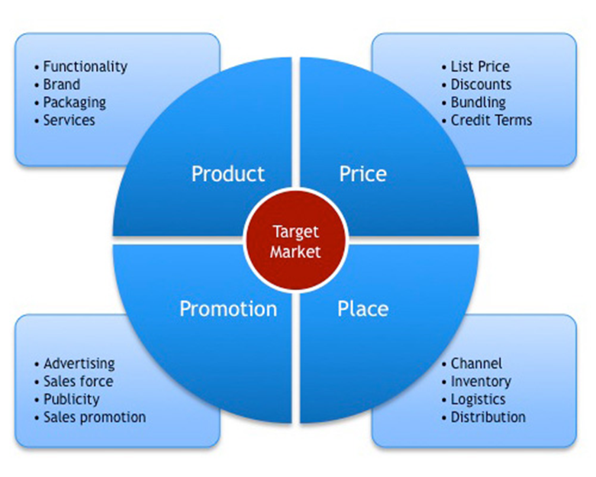
Product:
“Product” refers to the goods and services you offer to your customers. Apart from the physical product itself, there are elements associated with your product that customers may be attracted to, such as the way it is packaged.
Other product attributes include quality, features, options, services, warranties, and brand name. Thus, you might think of what you offer as a bundle of goods and services. Your product’s appearance, function, and support make up what the customer is actually buying.
Your product bundle should meet the needs of a particular target market. For example, a luxury product should create just the right image for “customers who have everything,” while many basic products must be positioned for price conscious consumers.
Other important aspects of product may include an appropriate product range, design, warranties, or a brand name. Customer research is a key element in building an effective marketing mix. Your knowledge of your target market and your competitors will allow you to offer a product that will appeal to customers and avoid costly mistakes.

Price:
“Price” refers to how much you charge for your product or service. Determining your product’s price can be tricky and even frightening. Your pricing approach should reflect the appropriate positioning of your product in the market and result in a price that covers your cost per item and includes a profit margin.
Price Skimming strategy: Price skimming is a product pricing strategy by which a firm charges the highest initial price that customers will pay and then lowers it over time. As the demand of the first customers is satisfied and competition enters the market, the firm lowers the price to attract another, more price-sensitive segment of the population.
Penetration strategy: Market penetration pricing is a pricing strategy that sets a low initial price for a product. The goal is to quickly attract new customers based on the low cost. The strategy is most effective for increasing market share and sales volume while discouraging competition.
Volume Discounts: You give discounts for wholesale buyers.
Product/Services Bundles: You put in similar or dissimilar products together and sell them as a bundle at a discounted price.
Seasonal pricing: means according to seasons the rate are high or vice versa. Like Narran Khagan rates are high in summers.

Place:
“Place” refers to the distribution channels used to get your product to your customers. If, for example, you own a small retail store or offer a service to your local community, then you are at the end of the distribution chain, and so you will be supplying directly to the customer.
If you want to have wider distribution for your product, you can sell it through a third party, either a retailer or wholesaler, who will then resell the product to their customers. This distribution strategy also reduces the pressure of running a distribution system.
Exclusive distribution: This strategy restricts your product distribution to only one reseller. The reseller will have exclusive rights to sell your product or service, and in return, you may also be the sole supplier. This works more effectively with specialty products that you can promote as prestigious because you are the sole supplier and the intermediary is the sole reseller.

Promotion:
Promotion” refers to the advertising and selling part of marketing. It is how you let people know what you’ve got for sale. The purpose of promotion is to get people to understand what your product is, what they can use it for, and why they should want it. You want the customers who are looking for a product to know that your product satisfies their needs. To be effective, your promotional efforts should contain a clear message targeted to a specific audience reached via an appropriate channel. Your target audience will be the people who use or influence the purchase of your product. Your message must be consistent with your overall marketing image, get your target audience’s attention, and elicit the response you desire, whether it is to purchase your product or to form an opinion.

MARKETING WHEEL OF FORTUNE
The first step of introduction of any product starts with:
- Customer, product and competitor research: customer research means asked and listen to the customer needs regarding the current product and the features that are missing according to the customer needs. Product research basically what you do and come up with your product offering that to what extend your product meet the customer needs. In competitor research you will find out what your competitor offering which kind of features they are providing in the product. Once you understand and map the difference that we will go for the next step.
- Product development: would means to establish a prototype of a product test it and finalize a product according to the needs of the customer.
- Pricing: depending upon the target market for your product offering, if you are a low cost provider than you have a massive production but charge low price. On the other hand if you are targeting a small niche that probably you will get high profit and charge high price for it.
- Label and Packaging: Your packaging is the gold star of your marketing mix – it can dictate how well your strategy is working, and it involves each one of the points above. Packaging is what shows off your product in the best light, displays the price and value of the product, communicates the product’s benefits to consumers, and it what physically appears in your various distribution points. Your product may be the very best on the market, but its packaging needs to be the main tool that represents this. It’s the first thing people see, and it has the ability to catch or divert their attention within seconds. Labeling is like the color theme highlights the brand. Labeling the uniqueness of our product.
- Distribution: Distribution is ensuring that your product should reach to the nearest point for the sale. It’s the choice of a producer to engage a third party who will pick up the product and safely transport it to the nearest store or he will do it by his own.
Distribution can make or break a company. A good distribution system quite simply means the company has greater chance of selling its products more than its competitors. The company that spreads its products wider and faster into the market place at lower costs than its competitors will make greater margins absorb raw material price rise better and last longer in tough market conditions. Distribution is critical for any type of industry or service. The best price product, promotion and people come to nothing if the product is not available for sale at the points at which consumers can buy.
- Advertisement and promotion: Do publicity, once the customer is aware of your product than he will decide to buy your product of go for the competitor product. If the customer will satisfy with your product than he will do a publicity by word of mouth.
- Sales: Include “operations and activities involved in promoting and selling goods or services.”
- Customer service: Customer service helpline are very annoying for any business. But they are most useful for finding out the missing features of the product as well as they play a role in doing research and development.

SMALL BUSINESS MARKETING IS DIFFERENT:
- Budget difference: Multinational Corporations have their budget for promotion and advertisement in millions. But the competitors like SME’s (small medium enterprises) may not have that much budget for the promotion.
- Staffing difference: Dedicated staff, dedicated marketing employees who are willing to come with creative ideas. But in SMEs the entrepreneur is solely responsible for this and he has not that much staff. Now SMEs outsource for the advertisement.
- Creative Difference: in large companies they will engage many different advertisement companies for creative ideas. But in case of entrepreneur there is some limitations.
- Strategic difference: the focus of the large companies is what their brand image in next 30 years. But in case of SMEs they focus on operational sides.

