Lecture 14
The Strategic Management Process

Strategic management is a continuous process that consists of nine steps:
Step 1. Develop a clear vision and translate it into a meaningful mission statement.
Step 2. Assess the company’s strengths and weaknesses.
Step 3. Scan the environment for significant opportunities and threats facing the business.
Step 4. Identify the key factors for success in the business.
Step 5. Analyze the competition.
Step 6. Create company goals and objectives.
Step 7. Formulate strategic options and select the appropriate strategies.
Step 8. Translate strategic plans into action plans.
Step 9. Establish accurate controls.

First two steps had been already studied in previous lecture.

Step 3: Scan for Opportunities and Threats:
Once entrepreneurs have taken an internal inventory of company strengths and weaknesses, they must turn to the external environment to identify any opportunities and threats that might have a significant impact on the business. Opportunities are positive external options that a firm can exploit to accomplish its mission, goals, and objectives. The number of potential opportunities is limitless; therefore, the key is to focus on the most promising opportunities that fit most closely with the company’s strengths and core competencies. That requires entrepreneurs to say “no” to opportunities, even promising ones, which do not fit their companies’ strategic vision.

What to look for in Identifying Company’s Opportunities?
- Utilizing existing company skills or technological know-how to enter new product lines or new businesses. E.g. Savor foods introduce fast food with the name of Savor crispo.
- Falling trade barriers in attractive foreign markets. E.g. The North American Free Trade Agreement (NAFTA) is a treaty entered into by the United States, Canada, and Mexico to promote free trade among the partners of the treaty.
- Acquiring rival firms or companies with attractive technological expertise or capabilities. E.g. Daraz being overtaken by Ali baba. Whatsapp is being overtaken by Facebook.
- Serving additional customer groups or market segments. E.g. Careem started bike and pickup service additional to luxury and affordable cars service for catering different segments.
- Expanding into new geographic markets.
- Expanding the company’s product line to meet a broader range of customer needs. E.g. Khaadi started chapter 2

Threats are negative external forces that inhibit a company’s ability to achieve its mission, goals, and objectives. Threats to the business can take a variety of forms, such as new competitors entering the local market, a government mandate regulating a business activity, an economic recession, rising interest rates, mounting energy prices, or technology advances making a company’s product obsolete. For instance, the growing reach of cellular phone networks and advances in smart phone technology pose a threat to companies that provide traditional landline phone service and equipment.

What to look for in Identifying Company’s Threats:
- Increasing intensity of competition among industry
- Slowdowns in market growth.
- Likely entry of potent new competitors. Gourmet introduces gourmet cola for price sensitive customers.
- Growing bargaining power of customers or suppliers.
- A shift in buyer needs and tastes away from the industry’s product. Cell phone diminishes the market for wrist watches.
- Adverse demographic changes that threaten to curtail demand for the industry’s product. E.g. for diaper manufacturing company Japan would not be a good option because of low birth rate.
- Vulnerability to unfavorable industry driving forces.
- Restrictive trade policies on the part of foreign governments. E.g. India has imposed 200 percent import duty on Pakistani products.
- Costly new regulatory requirements.

The Power of External Market Forces (PESTEL Analysis)
Six foundational macro forces create change in industries and the markets they serve:
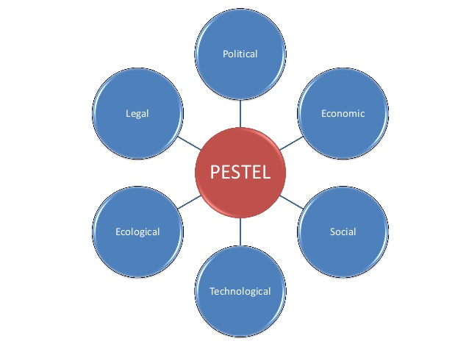

1. Political
These determine the extent to which government (democratic, dictatorship and monarchy) and government policy may impact on an organization or a specific industry. This would include political policy and stability as well as social and employment legislation, environment legislation, trade, fiscal and taxation policies too.

2. Economic Factors:
These factors impact on the economy and its performance, which in turn directly impacts on the organization and its profitability. Factors include interest rates, inflation, employment or unemployment rates, labor cost, raw material costs and foreign exchange rates.

3. Social Factors:
These factors focus on the social environment and identify emerging trends. This helps a marketer to further understand their customers’ needs and wants. Factors include changing family demographics, education levels, cultural trends, attitude changes and changes in lifestyles.

4. Technological Factors:
These factors consider the rate of technological innovation and development that could affect a market or industry. Factors could include changes in digital or mobile technology, automation, research and development. There is often a tendency to focus on developments only in digital technology, but consideration must also be given to new methods of distribution, manufacturing and also logistics.

5. Environmental Factors:
These factors relate to the influence of the surrounding environment and the impact of ecological aspects. With the rise in importance of CSR (Corporate Sustainability Responsibility), this element is becoming more important. Factors include climate, recycling procedures, carbon footprint, waste disposal and sustainability

6. Legal Factors:
An organization must understand what is legal and allowed within the territories they operate in. They also must be aware of any change in legislation and the impact this may have on business operations. Factors include employment legislation, consumer law, healthy and safety, international as well as trade regulation and restrictions.
Political factors do cross over with legal factors; however, the key difference is that political factors are led by government policy, whereas legal factors must be complied with.

Reference:
https://blog.oxfordcollegeofmarketing.com/2016/06/30/pestel-analysis/

