HANDOUTS
LECTURE 5
Entrepreneurship and the Youth

- Young people make up 17 percent of the world’s population, but 40 percent of its unemployed.
- Global unemployment rate is 4.5percent, while the world youth unemployment rate is 12.6 percent.

Venture Capitalist
A venture capitalist (VC) is an investor that provides capital to firms exhibiting high growth potential in exchange for an equity stake. This could be funding startup ventures or supporting small companies that wish to expand but do not have access to equities markets. Venture capitalists are willing to risk investing in such companies because they can earn a massive return on their investments if these companies are a success.
(Investopedia: https://www.investopedia.com/terms/v/venturecapitalist.asp)

Two Most Powerful Words?
Two most powerful words are “I am”. These two words show that how good you are.

Markets are Real but Ruthless
Market do not care about emotions they value business. If you give them business they will accept you and if you are not giving business to the market, you will be rejected.

Times are changing……
- Scientists Turn Entrepreneurs
- S&T (science and technology) Research Budget is increasing
- Research Output is Higher

“When some of these [academics]
Become millionaires and ride Porsches, the wives of others will needle them to go in this direction”

Sushanto Mitra, CE-Society for Innovation and Entrepreneurship at IIT-B

What and How????
- Faculty Entrepreneurship
- Connecting with VCs
- Sabbaticals and Start Ups
- File Patents
- Take Equity
- Setup Incubators
- PhD theses for Potential IP
- Reducing Teaching Load

What's Happening?
- Cultural Change in Institutions
E.g. Person who started coffee culture in Pakistan is Liaquat Ali khan. He brought Gloria Jeans.
- Research with an Application Lens
- Student-Professor Relationship to Partnership
- Sponsored or Collaborative research
- Risk Takers

Not Impact Factors But
Imp ACT

Smart Risk T aking Money Making Entrepreneur

Scientists Turn Entrepreneurs Recipe
1. Get out of your comfort zone
2. Take risk
3. Network/ socialize
4. Approachable
5. Think big
6. Firm strategy

Things to do…

e.g. Burning brownie: The person (Ammar Mumtaz)who own the business burning brownie started his business from a small rack at a local petrol pump to a full fledge bakery. He is an entrepreneur.

e.g. Patari (online music business): Started off their business from his hostel room and now they are covered internationally.

Entrepreneurship ecosystems:

Cult status in policy speeches
Holy Grail for governments around the world

WHY????

ESPECIALLYWHEN NUMEROUS VCs BELIEVE Entrepreneur are (Myths)…

- Firstborn….ONLY born

- Belong to a entrepreneurial family

- School/college dropouts

- Had weird relationship with father

Entrepreneurship: main contributions
- Employment
- Innovation
- Growth
- Local and Regional Development
e.g. Khaadi: Started off their business from a local outlet in Karachi and now it is an international brand.
- Equalization of Opportunities
- Economic Power Dissemination

New Generation of Dynamic Entrepreneur:

It’s the young people who are becoming entrepreneur
- Middle class families
- University graduates
- Entrepreneurial teams
- Start young

5 initial motivations are:
- To achieve self realization

- To put their knowledge into practice

- To increase their income

- To be their own boss

- To contribute to society

Advantage of promoting youth entrepreneurship
- More employers
- Employees who better understand business
- More innovative and socially responsible enterprises
- More jobs (most likely jobs for other young people)
- Better informed consumers

Transitions in the process of Youth Entrepreneurship Development
- Pre-entrepreneurs(15-19)
- Budding Entrepreneurs(20-25)
- Emergent Entrepreneurs(26-29)

The Entrepreneurial Process

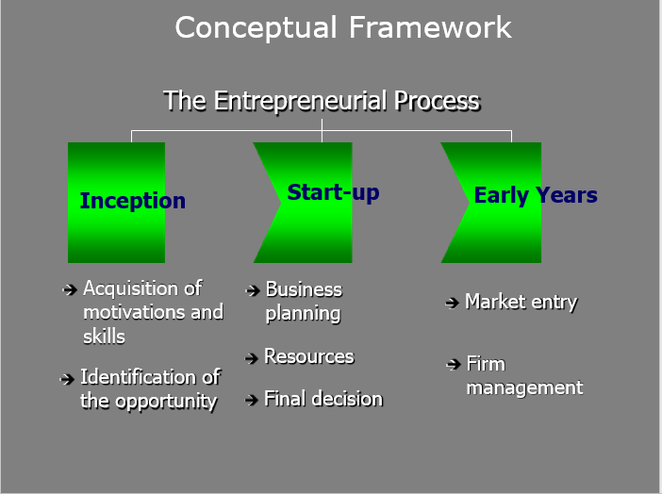

3F’s that provide you the resources for your new business are family, friends and fools (those who don’t know you).

The Entrepreneurial Development System

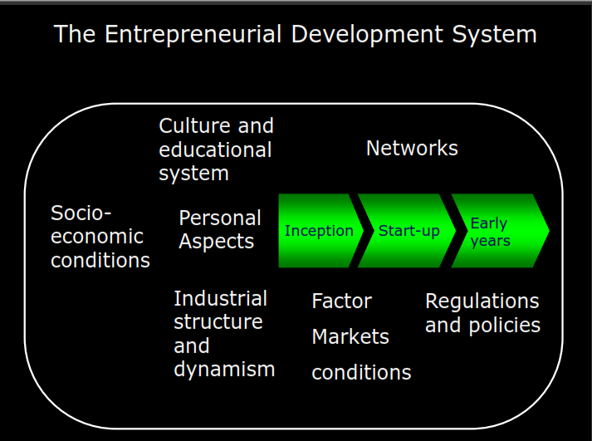

A factor market is a market where factors of production are bought and sold, such as the labor market, the physical capital market, the market for raw materials, and the market for management or entrepreneurial resources. (Source: Wikipedia)
So factor market conditions include cost pf production, raw material prices, wage rate etc.

Key factors influencing entrepreneurial process
1. Technical knowledge (university)
2. Entrepreneurial competencies
3. Entrepreneurial teams
4. Projects profile
5. Networks
6. Bootstrapping

