COMSATS University Islamabad, Virtual Campus
MGT210 Principles of Marketing
Lecture 16 Handouts

New Product Development and Product Life Cycle Strategies

New product development is the development of original products, product improvements, product modifications and new brands through the firm’s own product development efforts. New products are essential for the continuation of the company. New products aren’t easy to find. There are eight major steps in the product development process.

- Idea generation: the systematic search for new-product ideas. Ideas can be found via internal sources, but also external idea sources. These can be distributors, suppliers, but also competitors. Crowdsourcing means inviting broad communities of people – customers, employees, independent scientists and researchers and even the public at large – into the new-product innovation process.
- Idea screening: screening new-product ideas to spot good ideas and drop poor ones as soon as possible.
- Concept development and testing: Product concept is a detailed version of the new product idea stated in meaningful consumer terms. Concept testing means testing new product concepts with a group of target consumers to find out if the concepts have strong consumer appeal.
- Marketing strategy development: designing an initial marketing strategy for a new product based on the product concept. It consists of three parts: describing the target market and value proposition, outlining the budgets and lastly describing the long-term marketing mix strategy.
- Business analysis: is a review of the sales, cost and profit projections for a new product to find out whether these factors satisfy the company’s objectives.
- Product development: developing the product concept into a physical product to ensure that the product idea can be turned into a workable market offering.
- Test marketing: the stage of new product development in which the product and its proposed marketing program are tested in realistic market settings. This can be done in Standard, controlled test markets and simulated test markets.
- Commercialization: introducing a new product into the market.

Customer-centered new product development: new product development that focuses on finding new ways to solve customer problems and create more customer satisfying experiences. Team-based new product development is an approach to developing new products in which various company departments work closely together, overlapping the steps in the product development process to save time and increase effectiveness. Systematic new product development is preferred over haphazard and compartmentalized development. Innovation can be messy and difficult to manage, especially in turbulent times.

Product Life Cycle
The product life cycle (PLC) is the course of product’s sales and profits over its lifetime. It involves five distinct stages:
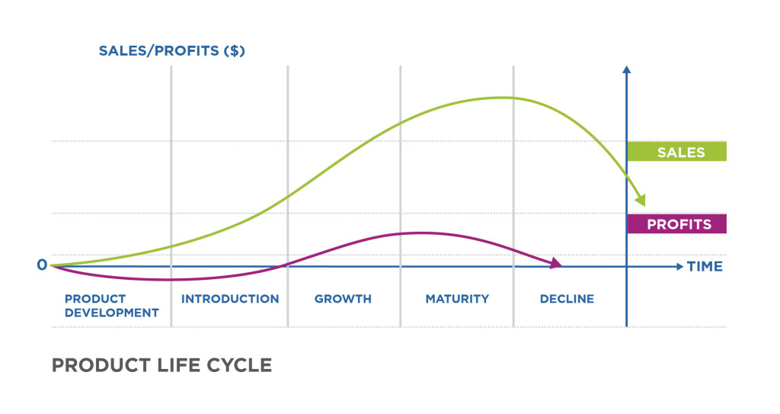

- Product development: development of the idea without any sales.
- Introduction: slow sales growth when the product is introduced.
- Growth: period of rapid acceptance.
- Maturity: period of sale slowdown because of acceptance by most potential buyers.
- Decline: the period when sales fall and the profit drops.

The PLC concept can also be applied to styles, fashions and fads. A style is a basic and distinctive mode of expression. Fashion is a currently accepted or popular style in a given field. Fad is temporary period of unusually high sales driven by consumer enthusiasm and immediate product or brand popularity. Companies must continually innovate to keep up with the cycle. There are different strategies for each stage.

- The introduction stage is the PLC stage in which a new product is first distributed and made available for purchase. Profits are generally low and the initial strategy must be consistent with product positioning.
- The growth stage is the stage in which a product’s sales start climbing quickly. Profits increase and the firm faces a trade-off between high market share and high current profit.
- In the maturity stage, products sales are growing slowly or level off. The company tries to increase consumption by finding new consumers, also known as modifying the market. The company might also try to modify the product by changing characteristics.
- In the decline stage, the product’s sales are declining or dropping to zero. Management might decide to maintain the brand, reposition it or drop a product from the line.

When introducing product in international markets, it must be decided which products to offer in which countries and how these product should be adapted. Packaging issues can be subtle, from translating issues to different meanings of logos.

