COMSATS University Islamabad, Virtual Campus
MGT210 Principles of Marketing
Lecture 15 Handouts

Service Marketing; Building Customer Value and New Product Development Process
Services marketing
Services can involve high customer contact, where the service is directed at people, as in the case of hairdressing and healthcare. Or there is low customer contact, as in dry cleaning and automated car-washes, where the services arc directed at objects. Services can be people-based (e.g. consultancies, education) or equipment-bound (e.g. vending machines, bank cash dispensers). People-based services can be further distinguished according to whether they rely on highly professional staff, such as legal advisers and medical practitioners, or unskilled labor, such as porters and caretakers. The wide variety of service offerings means that service providers must address the problems specific to their service when seeking to create and maintain a competitive advantage. Despite this heterogeneity across sectors, there are a few characteristics that are unique to services.
Firms must decide upon four service characteristics when designing marketing programs.
- Service intangibility: services cannot be seen, tasted, felt, heard or smelled before they are bought.
- Service inseparability: service are produced and consumed at the same time and cannot be separated from their providers.
- Service variability: the quality of services may greatly vary depending on who provides them and when, where and how.
- Service perish-ability: services cannot be stored for later sale or use.

Service Profit Chain
The service profit chain is the chain that links service firm profits with employee and customer satisfaction. This chain consists of five links: internal service quality, satisfied and productive service employees, greater service value, satisfied and loyal customers and ultimately healthy service profits and growth. Service marketing is more than traditional external marketing; it also consists of internal and interactive marketing. Internal marketing involves orienting and motivating customer contact employees and supporting service people to work as a team to provide customer satisfaction. Interactive marketing involves training services employees in the fine art of interacting with customers to satisfy their needs.
Service marketers need to manage service differentiation, making sure that they stand out amongst competitors. They also need to manage service quality, which can be harder to define than product quality. Lastly, they need to manage service productivity by ensuring employees are skilful and implementing the powers of technology.
New Product Development
Given the rapid changes in taste, technology and competition, a company cannot rely solely on its existing products to sustain growth or to maintain profitability. The firm can hope to maintain market and profit performance only by continuous product innovation. Product innovation encompasses a variety of product development activities - product improvement, development of entirely new ones, and extensions that increase the range or number of lines of product the firm can offer. Product innovations are not to be confused with inventions. The latter are a new technology or product which may or may not deliver benefits to customers. An innovation is defined as an idea, product or piece of technology that has been developed and marketed to customers ‘who perceive it as novel or new.
We also need to distinguish between obtaining new products through acquisition - by buying a whole company, a patent or a license to produce someone else's product and through new-product development in the company's own research and development department. As the costs of developing and introducing major new products have climbed, many large companies have decided to acquire existing brands rather than to create new ones. Other firms have saved money by copying competitors' brands or by reviving old brands. These routes can contribute to a firm's growth and have both advantages and limitations.
New product development refers to original products, product improvements, product modifications, and new brands developed from the firm’s own research and development.
New Product Development Process
The new-product development process for finding and growing new products consists of nine main steps (see Figure)
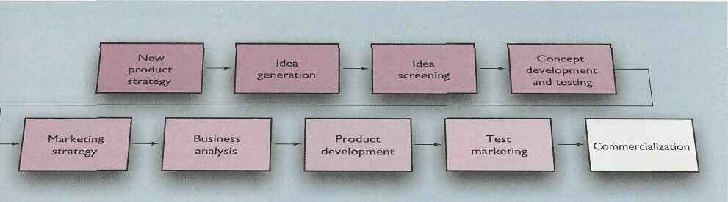
New Product Strategy
Successful innovative companies are placing more emphasis upon the use of definitive strategy statements or a product innovation charter (PIC). The PIC draws managers' attention to the reasons or rationale behind the firm's search for innovation opportunities, the product/market and technology to focus on, the objectives (market share, cash flow, profitability, etc.) to be achieved, and guidelines on the nature or level of innovativeness that will sell the new product. The charter spells out the priority that managers should place on developing break- through products, changing existing ones and imitating competitors' products.
- Idea Generation
The PIC should then direct the search for new-product ideas. Idea generation should be systematic rather than haphazard. Otherwise, although the company will find many ideas, most will not be good ones for its type of business. A company typically must generate many ideas to find a few good ones. A recent survey found that of 100 proposed new product ideas, 39 begin the product development process, 17 survive the development process, 8 reach the marketplace and only 1 eventually reaches its business objectives. To obtain a flow of new-product ideas, the company can tap many sources. Chief sources of new-product ideas include internal sources, and external sources comprising of customers, competitors, distributors and suppliers.
- Internal Sources:
Many new-product ideas come from internal sources within the company. The company can find new ideas through formal research and development. It can pick the brains of its scientists, engineers, designers and manufacturing people. Or company executives can brainstorm new-product ideas. The company's sales- people are another good source of ideas because they are in daily contact with customers. Formal or informal suggestion schemes can also be used to tap staffs ideas.
- Customers:
Almost 28 per cent of all new-product ideas come from watching and listening to customers. The company can conduct surveys to learn about consumer needs and wants. It can analyze customer questions and complaints to find new products that better solve consumer problems. Company engineers or salespeople can meet with customers to get suggestions. General Electric’s Video Products Division, Sony, Toyota and many other effective innovators are known to have their design engineers talk with final consumers to get ideas for new products. Many new ideas come from simply observing consumers. Customers, however, may not always know their future needs and wants.
- Competitors:
About 30 per cent of new-product ideas come from analyzing competitors' products. The company can watch competitors' ads and other communications to get clues about their new products. Companies buy competing products, take them apart to see how they work, analyze their sales, and decide whether the company should bring out a new product of its own.
- Distributers, Suppliers and Others:
Resellers are close to the market and can pass along information about consumer problems and new-product possibilities. Suppliers can tell the company about new concepts, techniques and materials that can be used to develop new products. Other idea sources include trade magazines, shows and seminars; government agencies; new-product consultants; advertising agencies; marketing research firms; university, commercial laboratories and science parks; and inventors.
- Idea Screening
The purpose of idea generation is to create a large number of ideas. The purpose of the succeeding stages is to reduce that number to a manageable few which deserve further attention. The first idea-reducing stage is idea screening. The purpose of screening is to spot good ideas and drop poor ones as soon as possible. As product development costs rise greatly in later stages, it is important for the company to go ahead only with those product ideas that will turn into profitable products.
- Concept Development and Testing
Attractive ideas must now be developed into product concepts. It is important to distinguish between a produce idea, a product concept and a product image. A product idea is an idea for a possible product that the company can see itself offering to the market. A product concept is a detailed version of the idea stated in meaningful consumer terms. A product image is the way consumers perceive an actual or potential product.
- Concept Development
Suppose a car manufacturer figures out how to design an electric car that can go as fast as 90 km per hour and as far as 170 km before needing to be recharged. The manufacturer estimates that the electric car's operating costs will be about half those of a regular car. This is a product idea. Customers, however, do not buy a product idea; they buy a product concept. The marketer's task is to develop this idea into some alternative product concepts, find out how attractive each concept is to customers, and choose the best one. The marketer might create the following product concepts for the electric car.
Concept 1. A moderately priced subcompact designed as a second family car to be used around town. The car is ideal for running errands and visiting friends.
Concept 2. A medium-cost sporty compact appealing to young people.
Concept 3. An inexpensive subcompact 'green' car appealing to environmentally conscious people who want practical transportation and low pollution.
To increase the likelihood of concept acceptance, some firms involve the customer (or potential customer) in concept development.
- Concept Testing
Concept testing calls for testing new-product concepts with a group of target consumers. The concepts may be presented to consumers symbolically or physically. For some concept tests, a word or picture description might be sufficient. However, a more concrete and physical presentation of the concept will increase the reliability of the concept test. Today, marketers are finding innovative ways to make product concepts more real to consumer subjects. For example, some are using virtual reality to test product concepts. Virtual reality Programmes use computers and censor devices (such as goggles or gloves) to simulate reality.

