COMSATS University Islamabad, Virtual Campus

MGT210 Principles of Marketing
Lecture 14 Handouts

Products, Services and Brands: Building Customer Value

A brand is a name, term, sign, symbol, design or a combination of these that identifies the products or services of one sell or group of sellers and differentiates them from those of competitors.
Packaging involves the activities of designing and producing the container or wrapper for a product. Innovative packaging can give a competitive advantage.
The final product and service decisions include labels that help identifying a product or brand and supporting services of the product.
Product line decisions
A product line is a group of products that are closely related because they function in a similar manner, are sold to the same customer groups, are marketed through the same types of outlets or fall within given price ranges. Major decisions include the product line length, which can be adjusted by product line filling (adding more items within present range) and line stretching (lengthen beyond current range).
Product mix decisions
A product mix (product portfolio) is the set of all product lines and items that a particular seller offers for sale. Product mix width is the number of different product lines, while length refers to the total number of items within the product lines. The product mix depth refers to the number of versions offered for each product in the line.
Branding
Brand equity is the differential effect that knowing the brand name has on customer response to the product or its marketing. Brand equity can be a powerful asset. Brand valuation is the process of estimating the total financial value of a brand. In order to build a strong brand, there are some major brand strategy decisions to be made.
- Brand positioning involves positioning the brand in the mind of the consumer.
- Brand name selection is important in order to select a good name. The brand name should say something about the service benefits and should be easy to pronounce and remember. It needs to be distinctive and extendable, easily translated and should be capable of legal protection.
- Brand sponsorship can be done via four ways.
  - A product can be launched as a national (manufacturer) brand or as a private brand or store brand. Another way is via licensed brands or a co-brand with another company.
  - A store brand is a brand created and owned by a reseller of a product or service.
  - Licensing involves lending the brand name to other manufacturers. Co-branding is the practice of using the established brand names of two different companies on the same product.
- Brand Development: When developing brands, companies have four choices.

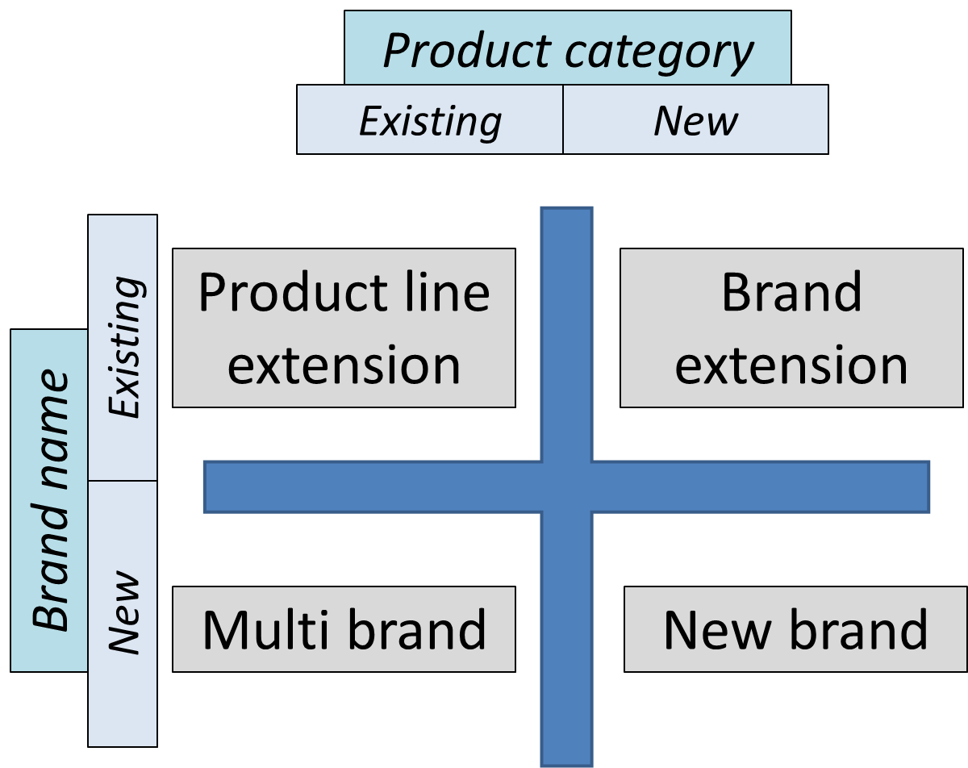

  - Line extensions occur when extending an existing brand name to new forms, colors, sizes, ingredients or flavors of an existing product category.
  - A brand extension extends a current brand name to new product categories.
  - Multiband means offering more than one brand in the same category.
  - New brands can be created when believed that the power of existing brands is fading.

