COMSATS University Islamabad, Virtual Campus

MGT210 Principles of Marketing
Lecture 12 Handouts

Customer-driven Marketing Strategy: Creating Value for Target Customers

Market targeting
Market targeting is the process of evaluating each market segment’s attractiveness and selecting one or more segments to enter. When evaluating segments, a marketer must look at segment size and growth, segment structural attractiveness and company objectives and resources.
A target market consists of a set of buyers sharing common needs or characteristics that the company decides to serve. There are several forms of market targeting.
- Undifferentiated (mass) marketing: a marketing coverage strategy in which a firm decides to ignore market segment differences and go after the whole market with one offer.
- Differentiated marketing or segmented marketing: a market-coverage strategy in which a firm decides to target several market segments and designs separate offers for each.
- Concentrated marketing (niche): a market-coverage strategy in which a firm goes after a large share of one or a few segments or niches.
- Micromarketing is tailoring products and marketing programs to the needs and wants of specific individuals and local customer segments. It includes local marketing: tailoring brands and promotions to the need and wants of local customer segments; cities, neighborhoods and even specific stores. It also includes individual marketing: tailoring products and marketing programs to the needs and preferences of individual customers, also called one-to-one marketing, customized marketing and markets-of-one marketing.
Companies need to consider a lot of factors when deciding upon a targeting strategy, such as available resources, market variability and competitors’ marketing strategies.

Differentiation and Positioning
Differentiation means differentiating the market offering to create superior customer value. Positioning is arranging for a market offering to occupy a clear, distinctive and desirable place relative to competing products in the mind of target consumers. A product position is the way the product is defined by consumers on important attributes: the place the product occupies in the consumers’ minds relative to competing products. Perceptual positioning maps show consumer perceptions of brands versus competing products.
To build profitable relationships, marketers must understand customer needs. When a company is differentiated by superior customer value, this can create a competitive advantage: an advantage over competitors gained by offering greater customer value, either by having lower prices or providing more benefits that justify high prices. The company can differentiate itself via product differentiation, service differentiation, channel differentiation, people differentiation or image differentiation.
When a company has multiple difference to promote, many marketers think the company should focus on one unique selling point (USP), while some others think they can promote more. Differences those are worthy to be promoted; need to be important, distinctive, superior, communicable, not easily copied, affordable and profitable.
The value proposition is the full positioning of a brand: the full mix of benefits on which it is positioned. There are multiple possible value propositions, of which five can be “winning”:

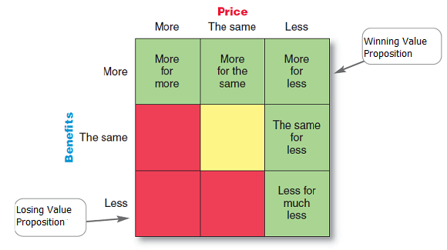

- More for more: upscale products and higher prices.
- More for the same: used to attack competitors by offering quality at a low price.
- The same for less: a good deal.
- Less for much less: a less optimal performance for a low price.
- More for less: ultimately winning, but difficult to actually achieve.

A positioning statement is a statement that summarizes company or brand positioning. It takes this form: To (target segment and needs) our (brand) is (concept) that (point of difference). Once a position is chosen, a company must take action to deliver and communicate the position to its target customers.

