COMSATS University Islamabad, Virtual Campus

MGT210 Principles of Marketing
Lecture 10 Handouts

Consumer Markets and Consumer Buyer Behavior

Psychological Factors
Psychological Factors are the factors that talk about the psychology of an individual that drive his actions to seek satisfaction. Some of the important Psychological Factors are:
- Motivation
- Perception
- Learning
- Beliefs and Attitudes
The above mentioned factors are explained as follows.

1) Motivation:
Motivation is an activated internal need state leading to goal-directed behavior to satisfy that need. A need may be defined as lack of something useful. A person can be motivated to buy a product for convenience, for style, for prestige, for self-pride or being at par with others.
Maslow placed the human needs in a five different levels in pyramid hierarchy, arranging the most basic level needs at the bottom of pyramid and as we move upwards stepwise we move to the next higher-level needs. As per Maslow’s theory, humans jump to the high level needs once the basic level needs are fulfilled.
These need are categorized into following steps
- Physiological needs: These needs are the basic needs such as food, water, sleep, warmth.
- Safety needs: People need to feel safe in a particular environment.
- Social needs: Human beings want to be loved and to be accepted by others. They want to attend groups, unions and contact with others.
- Esteem needs: People want to be admired and respected.
- Self-actualization needs: People who have all other needs below the pyramid want more and more. These needs show how you regard yourself and how you are regarded.
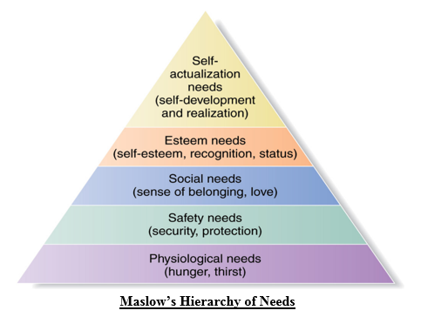
2) Perception
The consumer perception towards a particular product and the brand also influences his buying decision. The perception is the process through which the individual selects, organize and interpret the information to draw a meaningful conclusion. Such as, Apple iPhone is perceived as a premium brand and consumers are motivated to buy it to get associated with the elite class of the society.
There are three different processes which lead to difference in perception:
- Selective Attention - Selective attention refers to the process where individuals pay attention to information that is of use to them or their immediate family members. An individual in a single day is exposed to numerous advertisements, billboards, hoardings etc. but he is interested in only those which would benefit him in any way. He would not be interested in information which is not relevant at the moment.
- Selective Distortion - Consumers tend to perceive information in a way which would be in line to their existing thoughts and beliefs.
- Selective Retention - Consumers remember information which would be useful to them, rest all they forget in due course of time. Michael wanted to purchase a watch for his wife and thus he remembered the RADO advertisement which he had seen several days ago.
- Different people have different perceptions about the same product depending on their individual beliefs and attitudes which give rise to selective distortion. Thus, the marketer should try to understand the attitudes and beliefs of individuals and design the marketing campaigns to retain the consumers.
3) Learning
The individual’s learning depends on the skills, knowledge and intention. The skills are developed through practice while the knowledge and intention are acquired with the experience. There could be a conditional learning or a cognitive learning. Learning occurs through
- Drives
Internal stimulus that calls for action
- Stimuli
Objects that move drive to motive
- Cues
Minor stimuli that affect response
- Reinforcement
Feedback on action
In the conditional learning, the consumer derives learning from being conditioned to particular stimuli, i.e. when he is exposed to the similar situation, again and again, he develops a particular response towards it. While in the cognitive learning the individual applies all his knowledge, skill, attitudes, values and beliefs to find the solution of a problem and derive satisfaction out of it.
4) Beliefs and Attitudes
The individuals have certain beliefs and attitudes towards products on which their purchase decisions rests. These attitudes and beliefs are the tendency to respond to a given product in a particular way, and these make up the brand image that influences the consumer buying behavior. Thus, the marketers try to understand the attitudes and beliefs of the individuals and modify these through several marketing campaigns.
Types of Buying Decision Behavior
Wants are unlimited and the resources to satisfy these wants are limited. So, the consumers think rationally before buying any product. Buying a toothpaste is totally different from buying a luxury car. The more expensive the good is the more information is required by the consumer. There are four types of consumer buying behavior on the basis of buyer involvement while purchasing any product.
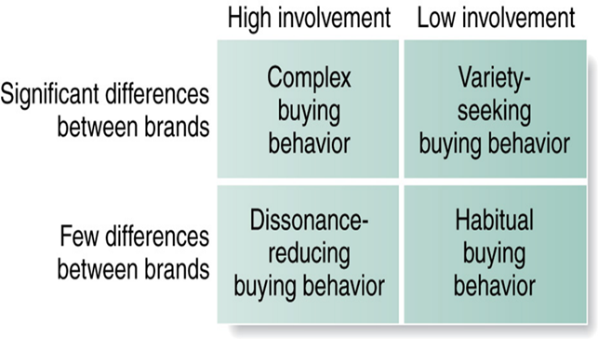
- High involvement: the term means when the consumer is highly involved while buying a product. Generally this situation happens in case of expensive or luxuries goods. Like while buying a diamond necklace a consumer is highly involved.
- Low involvement: this term means when the consumer is not highly involved while buying a product. It happens in case of low price goods. Like while buying toothpaste a consumer is not highly involved.
- Significant differences between brands: it means when there are significant differences between brands.
- Few differences between brands: it means when there are very little differences between brands.
- Complex buying behavior: when the consumer is highly involved in the buying and there is significant differences between brands then it is called complex buying behavior. So in this case the consumer must collect proper information about the product features and the marketer must provide detailed information regarding the product attributes. For eg. Consumer while buying a motor cycle is highly involved in the purchase and has the knowledge about significant differences between brands.
- Variety seeking behavior: in this case consumer involvement is low while buying the product but there are significant differences between brands. Consumers generally buy different products not due to dissatisfaction from the earlier product but due to seek variety. Like every time they buy different washing detergent just for variety. So it is the duty of the marketer to encourage the consumer to buy the product by offering those discounts, free samples and by advertising the product a lot.
- Dissonance buying behavior: here consumer is highly involved in the purchase but there are few differences between brands. Like consumer while buying a floor tiles buy them quickly as there are few differences between brands.
- Habitual buying behavior: in this case there is low involvement of the consumer and there are few differences between brands. The consumer buys the product quickly. For e.g. Toothpaste.

The Buying Roles
For many products, it is easy to identify the buyer. Men normally choose their shaving equipment and women choose their lipsticks. Other products involve a decision-making unit consisting of more than one person.
Consider the selection of a family automobile. The teenage son may have suggested buying a new car. A friend might advise the family on the kind of car to buy. The husband might choose the make. The wife might have definite desires regarding the car’s size and interior. The husband might make the financial offer. The wife might use the car more often than her husband.
Thus, we can distinguish five roles people might play in a buying decision:
i. Initiator: A person who first suggests the idea of buying the particular product or service.
ii. Influencer: A person whose view or advice influences the decision.
iii. Decider: A person who decides on any component of a buying decision; whether to buy, what to buy, how to buy, or where to buy
iv. Buyer: The person who makes the actual purchase.
v. User: A person who consumes or uses the product or service.
A company needs to identify these roles because they have implications for designing the product, determining messages, arid allocating the promotional budget. If the husband decides on the car make then the auto company will direct advertising to reach husbands. The auto company might design certain car features to please the wife. Knowing the main participants and their roles helps the marketer fine-tune the marketing program.

The Buyer Decision Process
The Consumer Decision Processes (also known as Buyer Decision Processes) refer to the decision-making stages that a consumer undergoes before, during, and after they purchase a product or service.
John Dewey introduced 5 stages which consumers go through when they are considering a purchase:
- Problem or need recognition: This is often identified as the first and most important step in the customer’s decision process. A purchase cannot take place without the recognition of the need. The need may have been triggered by internal stimuli (such as hunger or thirst) or external stimuli (such as advertising or word of mouth).
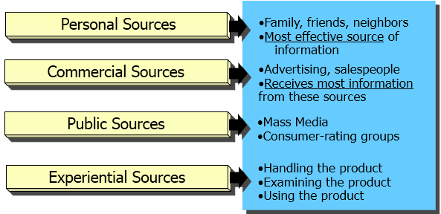
- Information search: Having recognized a problem or need, the next step a customer may take is the information search stage, in order to find out what they feel is the best solution. This is the buyer’s effort to search internal and external business environments, in order to identify and evaluate information sources related to the central buying decision. Your customer may rely on print, visual, online media or word of mouth for obtaining information.

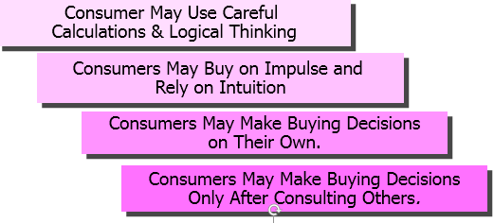
- Evaluation of alternatives: As you might expect, individuals will evaluate different products or brands at this stage on the basis of alternative product attributes – those which have the ability to deliver the benefits the customer is seeking. A factor that heavily influences this stage is the customer’s attitude. Involvement is another factor that influences the evaluation process. For example, if the customer’s attitude is positive and involvement is high, then they will evaluate a number of companies or brands; but if it is low, only one company or brand will be evaluated.
- Purchase decision: The penultimate stage is where the purchase takes place. Philip Kotler (2009) states that the final purchase decision may be ‘disrupted’ by two factors: negative feedback from other customers and the level of motivation to accept the feedback. For example, having gone through the previous three stages, a customer chooses to buy a new telescope. However, because his very good friend, a keen astronomer, gives him negative feedback, he will then be bound to change his preference. Furthermore, the decision may be disrupted due to unforeseen situations such as a sudden job loss or relocation.
- Post-purchase behavior: In brief, customers will compare products with their previous expectations and will be either satisfied or dissatisfied. Therefore, these stages are critical in retaining customers. This can greatly affect the decision process for similar purchases from the same company in the future, having a knock-on effect at the information search stage and evaluation of alternatives stage. If your customer is satisfied, this will result in brand loyalty, and the Information search and Evaluation of alternative stages will often be fast-tracked or skipped altogether.
On the basis of being either satisfied or dissatisfied, it is common for customers to distribute their positive or negative feedback about the product. This may be through reviews on website, social media networks or word of mouth. Companies should be very careful to create positive post-purchase communication, in order to engage customers and make the process as efficient as possible.
Buyer Decision Process for New Products
New Products are the Good, service or idea that is perceived by customers as new.
Stages in the Adoption Process
Marketers should help consumers move through these stages.
- Awareness: Consumer is aware of product, but lacks information.
- Interest: Consumer seeks information about new product.
- Evaluation: Consumer considers trying new product.
- Trial: Consumer tries new product on a small scale.
- Adoption: Consumer decides to make regular use of product.

