COMSATS UniversityIslamabad, VirtualCampus

MGT210 Principles of Marketing
Lecture 08 Handouts

Managing Marketing Information to Gain Customer Insights

Marketing Research:
The marketing Research is based on the following steps that are:
- Defining the research problem and research objectives
- Developing the research plan
- Primary and secondary data collection
- Implementing the research plan
- Interpreting and reporting the findings
The first two steps along with secondary data collection have been explained in previous handouts. Further steps are explained as under:
3. Planning Primary Data Collection:
Primary data is information collected for the specific purpose at hand. It can be collected via observational research, which gathers primary data by observing relevant people, actions and situations. Ethnographic research is a form of observational research that involves sending trained observers to watch and interact with consumers in their “natural environments”.
Primary data can also be collected via survey research, which gathers information by asking people questions about their knowledge, attitudes, preferences and buying behavior. Experimental research gathers primary data by selecting matched groups of subjects, giving them different treatments, controlling related factors and checking for differences in group responses.
Information can be collected via mail, telephone, and personal interviews or online. Mail questionnaires can be quite massive, while telephone information is also quickly gathered. Personal interviewing can be individual or group interviews. Online marketing research collects primary data online through Internet surveys, online focus groups, web-based experiments or tracking consumer’s behavior online. Online focus groups gather a small group of people online with a trained moderator to chat about a product, service or organization and gain qualitative insights about consumer attitudes and behavior.
It is often impossible to collect information from the entire population, so marketers often base conclusions on samples. A sample is a segment of the population selected for marketing research to represent the population as a whole. Three decisions regarding the sample need to be made: the sampling unit (who), sampling size (how many) and sampling procedure (how should they be chosen). There are probability samples, in which each member of the population has an equal chance of being included, such as simple random samples, stratified random samples and cluster samples. But there are also non-probability samples, such as convenience samples, judgment samples and quota sample categories. When collecting primary data, there are two research instruments: the questionnaire and mechanical devices. The questionnaire can be via email, phone or online and are flexible. Mechanical instruments can help monitor consumer behavior.
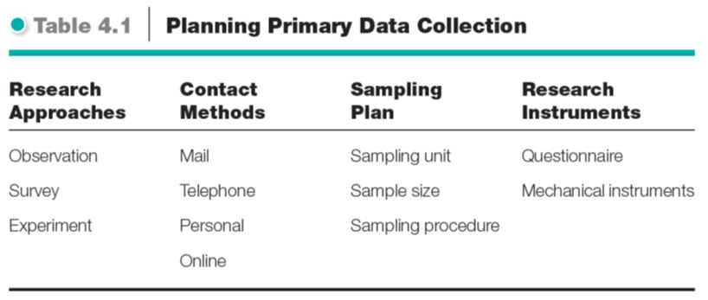
4. Implementing the Research Plan:
This step includes the collection and analysis of the data for the plan execution. Data once collected, is analyzed by the company to get the results. It means putting it into action. This means collecting, processing and analyzing the information.
- Interpreting and Reporting the Findings.
This step includes the interpretation of results that are found through the analysis of data collected in previous step. Based on findings, recommendations are made regarding the product or service that a company wants to offer. The interpretation should not only be done by the researchers, but also by the marketing managers who know about the problem and the decisions that need to be made.

