COMSATS University Islamabad, Virtual Campus

MGT210 Principles of Marketing

Lecture 04 Handouts

Planning Marketing: Partnering to Build Customer Relationships

Marketing Role in strategic planning (Top level or highest level of the firm)
  - Philosophy
  - Inputs for opportunities
  - SBU marketing strategies
Partner relationship management is the process of working closely with partners in other company departments to form an effective value chain that serves the customer, as well as partnering effectively with other companies in the marketing system to form a competitively superior value-delivery network.
Partnering with Other Company Departments
A value chain is a series of departments that carry out value-creating activities to design, produce, market, deliver, and support a firm’s products.
Example: Carrefour
Partnering with Others in the Marketing System
A value delivery network is made up of the company, suppliers, distributors, and ultimately customers who partner with each other to improve performance of the entire system.
Example: Toyota
Marketing Strategy and the Marketing Mix
Marketing mix is the marketing logic by which the business units hope to achieve its marketing objectives.

Customer-Driven Marketing Strategy
- Market segmentation is the division of a market into distinct groups of buyers who have distinct needs, characteristics, or behavior and who might require separate products or marketing mixes. Consumers can be grouped and served in various ways based on geographic, demographic, psychographic, and behavioral factors. The process of dividing a market into distinct group of buyers with different needs characteristics, or behavior who might require separate products or marketing mix is called market segmentation.
- A market segment is a group of consumers who respond in a similar way to a given set of marketing efforts.
- Target marketing is the process of evaluating each market segment’s attractiveness and selecting one or more segments to enter. A market segment consists of consumer who respond in a similar way to a given set of marketing segment.
- Market positioning is the arranging for a product to occupy a clear, distinctive, and desirable place relative to competing products in the minds of the target consumer. Thus, marketers plan positions that distinguish their products from competing brands and give them the greatest strategic advantage in their target market.
Developing an Integrated Marketing Mix
The marketing mix is the set of controllable tactical marketing tools—product, price, place, and promotion—that the firm blends to produce the response it wants in the target market.
Developing an Integrated Marketing Mix
The four Ps
- Product
- Price
- Place
- Promotion
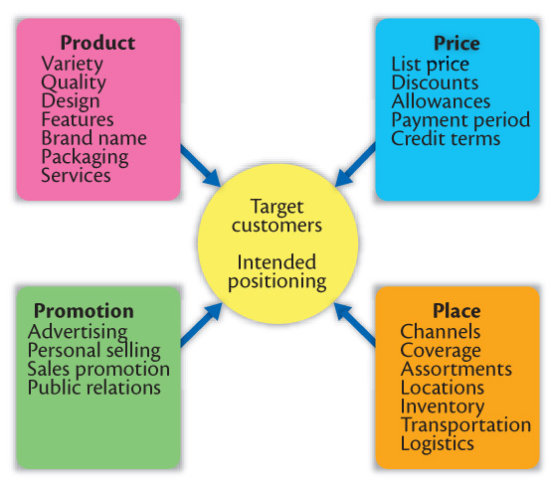
Product is the goods and services in combination that the company offers to the target market. Thus, a Ford Taurus product consist of nuts and bolts, spark plugs, pistons, headlights, and thousands of other parts. Ford offers several Taurus styles and dozens of optional features. The car comes fully serviced and with a comprehensive warranty that is as much a part of the product as the tailpipe.
Price is the amount of money customers have to pay to obtain the product.
Place is the company activities that make the product available to target customers.
Promotion is the activities that communicate the merits of the product and persuade target customers to buy it. Ford spends more than $1.2 billion each year on advertising to tell consumers about the company and its products.

Marketing Strategy and the Marketing Mix

The 4 Ps | versus | The 4 Cs
Product |  | Customer solution
Price |  | Customer cost
Place |  | Convenience
Promotion |  | Communication

Managing the Marketing Effort
The company wants to design and put into action the marketing mix that will best achieve its objectives in its target market.
Managing the marketing effort requires:
- Analysis, Planning, Implementing and Controlling

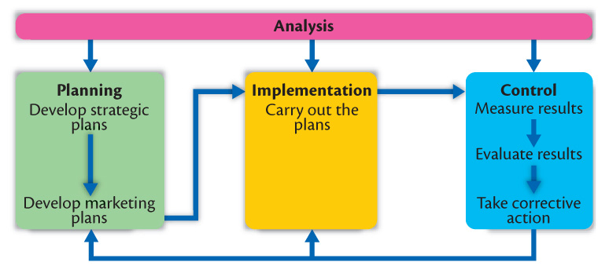
Marketing Analysis
Marketing analysis is the complete analysis of the company’s situation in a SWOT analysis that evaluates the company’s:
- Strengths
- Weaknesses
- Opportunities
- Threats

Managing the marketing function begins with a complete analysis of the company’s situation. The company must analyze its markets and marketing environment to find attractive opportunities and to avoid environmental threats. It must analyze company’s strength and weaknesses as well as current and possible marketing actions to determine which opportunities it can best pursue. Marketing provides input to each of the other marketing management function.
- Strengths include internal capabilities, resources, and positive situational factors that may help to serve company customers and achieve company objectives.
- Weaknesses include internal limitations and negative situational factors that may interfere with company performance.
- Opportunities are favorable factors or trends in the external environment that the company may be able to exploit to its advantage.
- Threats are unfavorable factors or trends that may present challenges to performance.
Market Planning
Planning is the development of strategic and marketing plans to achieve company objectives. Marketing planning involves deciding on marketing strategies that will help the company attain its overall strategic objectives.
Marketing strategy consists of the specific strategies for target markets, positioning, the marketing mix, and marketing expenditure levels. The marketing logic by which the business unit hopes to achieve its marketing objectives. In this section the planner explains how each strategy responds to the threats, opportunities, and critical issues spelled out earlier in the plan.
Market Planning
Sections of a marketing plan include:
- Executive summary
- Current marketing situation
- Threats and opportunities
- Objective and issues
- Action programs
- Budgets
- Controls

Marketing Implementation
- Implementing is the process that turns marketing plans into marketing actions to accomplish strategic marketing objectives. Implementation involves day to day, month to month activities that effectively put the marketing plan to work. Whereas, marketing planning addresses the “what” and “why” of marketing activities, implementation addresses the “who”, “where”, “when” and “how”.
- Successful implementation depends on how well the company blends its people, organizational structure, decision and reward system, and company culture into a cohesive action plan that supports its strategies.
Marketing Department Organization
- Functional
- Geographic
- Product
- Market or customer management
- Functional organization: This is the most common form of marketing organization with different marketing functions headed by a functional specialist.
  - Sales manager
  - Market research manager
  - Customer service manager
  - New product manager
Geographic organization:
- Useful for companies that sell across the country or internationally.
- Managers are responsible for developing strategies and plans for a specific region.
Product management:
- Useful for companies with different products or brands.
Managers are responsible for developing strategies and plans for a specific product or band.
Market or customer management organization:
- Useful for companies with one product line sold to many different markets and customers.
- Managers are responsible for developing strategies and plans for their specific markets or customers.
Customer management involves a customer focus and not a product focus for managing customer profitability and customer equity.
Controlling is measuring and evaluating results and taking corrective action as needed.
- Four step process: set, measure, evaluate, corrective action
Operating control involves checking ongoing performance against annual plan and taking corrective action as needed. Its purpose is to ensure that the company achieves the sales, profit, and other goals set out in its annual plan. It also involves determining the profitability of different products, territories, markets, and channels.
Strategic control involves looking at whether the company’s basic strategies are well matched to its opportunities. Marketing strategies and programs can quickly become outdated, and each company should periodically reassess its overall approach to the marketplace.
Marketing Control
A marketing audit is a comprehensive, systematic, independent, and periodic examination of a company’s environment, objectives, strategies, and activities to determine problem areas and opportunities and to recommend a plan of actions to improve the company’s marketing performance. The audit provides good input for a plan of action to improve the company’s marketing performance. The marketing audit provides good input for a plan of action to improve the company’s marketing performance.
Return on marketing investment (ROI)
Return on marketing investment (ROI) is the net return from a marketing investment divided by the costs of the marketing investment. Marketing ROI provides a measurement of the profits generated by investments in marketing activities.
Return on investment is also a common measure of managerial effectiveness. The ratio of net profit to investment.
Customer-Centered Measures
- Customer acquisition
- Customer retention
- Customer lifetime value

Return on Marketing

The Return on Marketing Investment measures how much revenue a marketing campaign is generating compared to the cost of running that campaign.
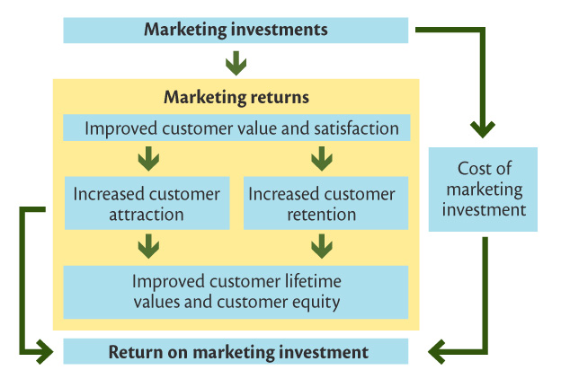

Effective marketers are driven to connect their time, energy and advertising spend with results that contribute to company growth. The Return on Marketing Investment answers the question, “are we recouping the time and money we spent developing and executing our marketing campaigns?”

