COMSATS University Islamabad, Virtual Campus

MGT210 Principles of Marketing

Lecture 03 Handouts

Steps in the Marketing Process
In the previous lectures the following steps in the marketing process were discussed.
Step 1: Understand customer needs and wants and the market
Step 2: Design customer driven marketing strategy
- Value and what to offer to the people and how you understand the customer
- Philosophy for designing a marketing strategy
  - Production concept
    - You need to make a product which is affordable and readily available at the very same time.
  - Product concept
    - Create an innovative product or a product of superior performance
  - Selling concept
    - The customer will not buy your product until and unless you make sound selling efforts.
    - Promoting your product and getting your product to the end customer
  - Marketing concept
    - Understanding the customer’s need and providing what the customer wants
  - Societal concept
    - Try to balance they pyramid of what society wants, what the consumer wants and what the company wants.
Step 3: Construct an integrated marketing program that delivers superior value.
- Integrated Marketing is an approach to creating a unified and seamless experience for consumers to interact with the brand/enterprise.

Step 4: Build profitable relationships and create customer delight.
- Customer Relationship Management (CRM): The overall process of building and maintaining profitable relationships by delivering superior customer value and satisfaction.
- Partner Relationship Management: Good relations should be managed with the inside partners, e.g. employees, and the outside partners, e.g. suppliers and distributers. The value delivery cannot be ensured unless and until you have a good relationship with your partners.
Step 5: Capture value from customers to create profits and customer equity
- Customer Share
  - How much the customer buys from your company
- Customer Equity
  - Lifetime value that a customer gives to a company

Company and Marketing Strategy: Partnering to Build Customer Relationship
This is a new chapter which has the following outline.
- Companywide Strategic Planning: Defining Marketing’s Role
- Planning Marketing: Partnering to Build Customer Relationships
- Marketing Strategy and the Marketing Mix
- Managing the Marketing Effort
- Measuring and Managing Return on Marketing Investment

Companywide Strategic Planning: Defining Marketing’s Role
The marketing strategies are guided by broader companywide strategic plans. Strategic planning is the process of developing and maintaining a strategic fit between the organization’s goals and capabilities and its changing market opportunities.
The steps of strategic planning are shown in the figure below. These will be discussed in detail later on.
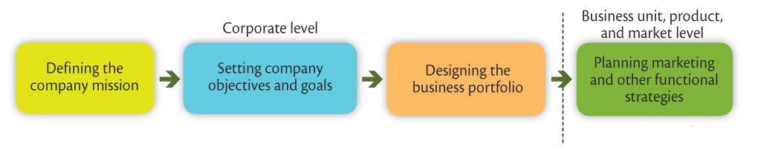

Defining the Company’s Mission
The mission statement gives the organization’s purpose and what it wants to accomplish in the larger environment. There may be two types of mission statements:
- Product-oriented mission statement: Focuses on the product or focuses on your offering
- Market-oriented mission statement: Defines the business in terms of satisfying basic customer needs
Out of the two, the market-oriented mission statement is better because it focuses on needs, and because products go obsolete and customer’s needs change, so the product-oriented mission statement will go obsolete.
“We provide the world’s best online search engine.” is a product-oriented mission statement of Google. Whereas, “We help you organize the world’s information and make it universally accessible and useful.” is the market-oriented mission statement of Google.

Setting Company Objectives and Goals
Business objectives will take input from the mission statement. Marketing objectives will be defined based on the business objectives. From the marketing objectives, strategies will be made.
- Engro Chemicals Example
  - Mission Statement: Helping farmers maximize their farm produce by providing quality plant nutrients and technical services upon which they can depend”
  - Business Objectives: Building profitable relationships by understanding their farmers farming challenges and then supplying them with balanced and cost effective nutrients at a price that allows the company to get a fair ROI.
  - Marketing Objective: Research on soil conditions and usage practices and come up with new products that serve farmers need better.
  - Marketing Strategy: Using mobile labs for free soil testing to understand their needs, educating farmers through advertisements and advisory services
Designing the Business Portfolio
The business portfolio is the collection of businesses and products that make up the company. There are different steps involved in designing the business portfolio.

Step 1: Analyzing Current Business Portfolio
Analyzing the current business portfolio is the process by which management evaluates the products and businesses making up the company. The following steps are involved.

- Identify key businesses making up the company
  - A strategic business unit (SBU) is a unit of the company that has a separate mission and objectives that can be planned separately from other company businesses.
    - Company division
    - Product line within a division
    - Single product or brand
- Assess the attractiveness of its various SBUs
- Decide how much support each SBU deserves
The Boston Group Approach/Growth Share Matrix
Growth share matrix is a portfolio planning method that evaluates a company’s strategic business units in terms of their market growth rate and relative share. The BCG growth share matrix is shown in the following figure.
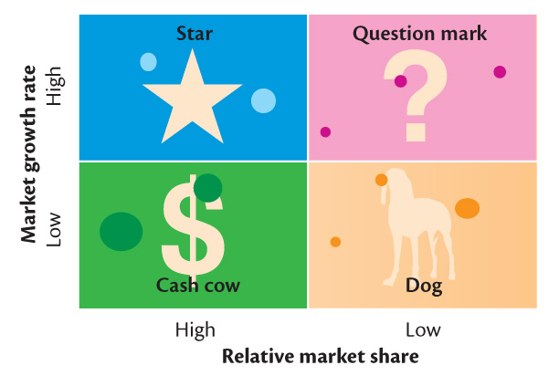

This approach helps to analyze which SBU needs more support. The strategic business units are classified as: Stars, Cash Cows, Question Marks and Dogs.
- Stars are high-growth, high-share businesses or products requiring heavy investment to finance rapid growth. They will eventually turn into cash cows.
- Cash cows are low-growth, high-share businesses or products that are established and successful SBUs requiring less investment to maintain market share.
- Question marks are low-share business units in high-growth markets requiring a lot of cash to hold their share.
- Dogs are low-growth, low-share businesses and products that may generate enough cash to maintain themselves but do not promise to be large sources of cash.

Problems and Limitations with Matrix Approaches
- Difficulty in defining and measuring market share and growth
- Time consuming
- Expensive
- Focus on current businesses, not future planning

Step 2: Shaping future Portfolio by developing strategies for growth and downsizing
The product/market expansion grid is a tool for identifying company growth opportunities through market penetration, market development, product development, or diversification.

The Product/Market Expansion Grid
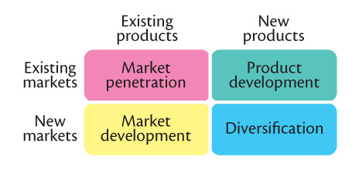
Product/market expansion grid strategies are
- Market penetration is a growth strategy increasing sales to current market segments without changing the product.
- Market development is a growth strategy that identifies and develops new market segments for current products.
- Product development is a growth strategy that offers new or modified products to existing market segments.

- Diversification is a growth strategy through starting up or acquiring businesses outside the company’s current products and markets.
Downsizing is the reduction of the business portfolio by eliminating products or business units that are not profitable or that no longer fit the company’s overall strategy.

