COMSATS University Islamabad, Virtual Campus

MGT210 Principles of Marketing

Lecture 02
Handouts

Designing a Customer-Driven Marketing Strategy
Marketing management is the art and science of choosing target markets and building profitable relationships with them. The aim is to find, attract, keep and grow the targeted customers by creating and delivering superior customer value. The target audience can be selected by dividing the market into customer segments (market segmentation) and selecting which segments to go after (target marketing). A company must also decide how to serve the targeted audience, by offering a value proposition. A value proposition is the set of benefits or values a company promises to deliver.
There are five alternative concepts that companies use to carry out their marketing strategy.
- The production concept: the idea that consumers will favor products that are available and highly affordable and that the organization should therefore focus on improving production and distribution efficiency.
- The product concept: the idea that consumers will favor products that offer the most quality, performance, and features and that the organization should therefore devote its energy to making continuous product improvements.
- The selling concept: the idea that consumers will not buy enough of the firm’s product, unless it undertakes a large-scale selling and promotion effort.
- The marketing concept: the idea that achieving organizational goals depends on knowing the needs and wants of target markets and delivering the desired satisfactions better than competitors do. It can be regarded as an “outside-in view”.
- The societal marketing concept is the idea that a company’s marketing decisions should consider consumer wants, the company’s requirements, consumers’ long-term interests and society’s long-term interests. Companies should deliver value in a way that maintains consumers and society’s well-being.

Constructing an Integrated Marketing Plan
A marketing strategy outlines which customers it will serve and how it will create value. The marketer develops an integrated marketing plan that will deliver value to customers. It contains the marketing mix: the tools used to implement the strategy, which are the four Ps: product, price, place and promotion.

Building Customer Relationships
The first three steps all lead to this one: building profitable customer relationships. Customer relationship management (CRM) is the overall process of building and maintaining profitable customer relationships by delivering superior customer value and satisfaction. The crucial part here is to create superior customer-perceived-value, which is the customer’s evaluation of the difference between all the benefits and all the costs of a marketing offer, in relation to those of competing offers and superior customer satisfaction, which is the extent to which a product’s perceived performance matches a buyer’s expectations. Customer delight can be achieved by delivering more than promised.

Customer relationships exist at multiple levels. They can be basic relationships or full partnerships and everything in between. In current times, companies are choosing their customers more selectively. New technologies have paved the way for two-way customer relationships, where consumers have more power and control. The marketing world is also embracing customer-managed relationships: marketing relationships in which customers, empowered by today’s new digital technologies, interact with companies and with each other to shape their relationships with brands. A growing part of this dialogue is consumer-generated marketing: brand exchanges created by consumers themselves, by which consumers are playing an increasing role in shaping their own brand experiences and those of other consumers.

Today’s marketers often work with a variety of partners to build consumer relationships. Partner relationship management means working closely with partners in other company departments and outside the company to jointly bring greater value to customers. These partners can be inside the company, but also outside the firm. The supply chain is a channel, from raw material to final product, and the companies involved can be partners through supply chain management.

Capturing Customer Value
The final step of the model involves capturing value. Customer lifetime value is the value of the entire stream of purchases that the customer would make over a lifetime of patronage. Companies must aim high in building customer relations, to make sure that customers are coming back. Good CRM can help increase the share of customer, the portion of the customer’s purchasing that a company gets in its product categories. Customer equity is the total combined customer lifetime values of all of the company’s customers. It is the future value of the company’s customer base.
When building relationships, it is important to build the right relationships with the right customers. Customers can be high- or low-profitable and short-term or long-term oriented. When putting these on two axes, a matrix of four terms appears.
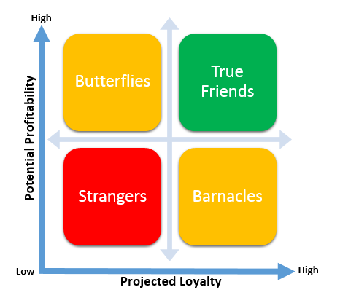
- Butterflies are profitable, but not loyal and have a high profit potential.
- True friends are both profitable and loyal and the firm should invest in a continuous relationship.
- Barnacles are loyal, but unprofitable. If they can’t be improved, the company should try to get rid of them.
- Strangers are not loyal and unprofitable; the company should not invest in them.

Today’s world is moving and changing fast. The economic crisis resulted in an uncertain economic environment, where consumers are more careful when spending their money. The technology boom of the digital age leads to an increase in connectedness and information. It provides marketers with new ways to track customers and create products based on their needs. It brought a new way of communicating and advertising. The most dramatic change in technology is the Internet, a vast public web of computer networks that connects users of all types all around the world to each other and an amazingly large information repository

